Hospitality and Tourism

Primary and Secondary Customer Profiles

Mr. Orr

**Selecting Profitable Target Markets**

Two important factors to consider when attracting a target market segment are

* The attractiveness of the segment (size, growth rate, income…)
* How well does it match the city’s resources, attractions, and capabilities?

Define your city’s:

1. Primary Customer Profile
2. Secondary Customer Profile

Describe them by a Demographic, Psychographic, Geographic and Behavioristic perspectives. Include a rationale for why they represent a valuable segment.

EXAMPLE:

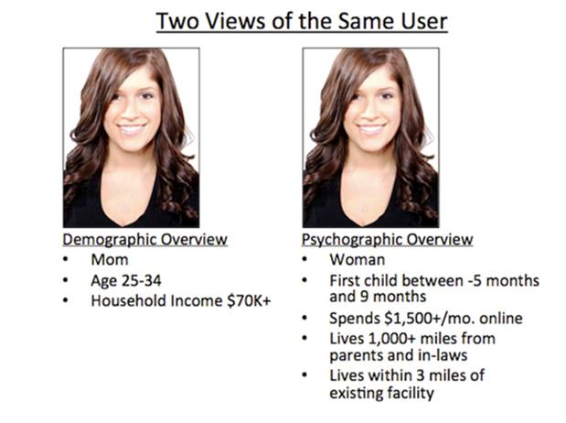

**Demographic Overview**

* Mom
* Age 25-34
* Household Income $70K+

**Geographic Overview**

* Lives 500 miles+ from parents and in-laws
* Lives within a 2 hour drive of our city

**Psychographic Overview**

* Married less than 5 years
* First child between -5 and 9 months

**Behavioristic Overview**

* Spends $1,500+/mo. online
* Takes two +5 day vacations a year
* Walks, bikes, or goes to the gym +5 days/week

She is the perfect consumer because of her moderate to high income and willingness to spend that income on numerous weeklong vacations. Her online footprint and spending habits make her a perfect candidate to view and consume our cities online destination and travel sites, and her active lifestyle fits our city’s hiking, biking trails and spring marathon/10k/5K.